1. What is Cost Share?
Project costs not borne by the sponsor – essentially expenses paid by the University or department to complete the project. Cost sharing is also known as matching, offset or in-kind contribution. Proposed cost share should always be part of the Internal Approval Form and included in the proposed budget sent to OSPA.
- http://www.uky.edu/EVPFA/Controller/files/BPM/E-50-2.pdf - UK Policy
2. Types of Cost Share
- Faculty Effort
- NIH Salary Cap
- Departmental Cost Sharing
- Unrecovered or Waived F&A
- Third Party Contributions

3. Cost Share Obligation/Commitment

When mandatory or voluntary cost sharing is specifically identified and described in the proposal budget and made a condition of the resulting award, the university has an obligation to record the costs in the accounting system. If cost share is noted on the Cost Share Information Form (CSIF) then it is considered a commitment. The CSIF form should be included with the PADR, and may be updated throughout the life of the project. Be sure to verify any additional information in the remarks section.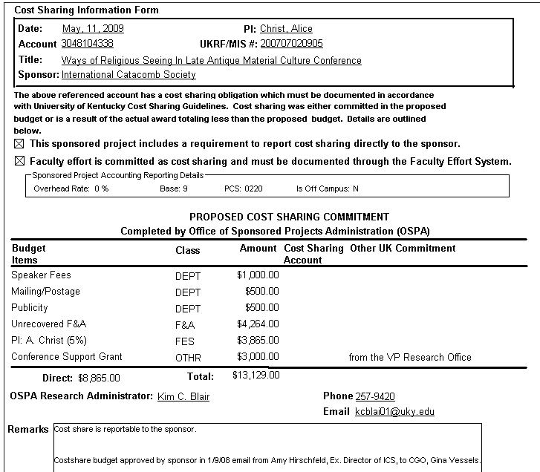

4. Reporting/Tracking of Cost Share
Expenses should be tracked in the system using the 304* WBS element and the cost share fund 0011890X00. There are no direct postings on the 10136- fund centers.
- Typically, the cost share fund used in CAFE will be 0011890300
- The cost share Fund can be found on t-code GMGRANTD on the Dimensions tab for each project. 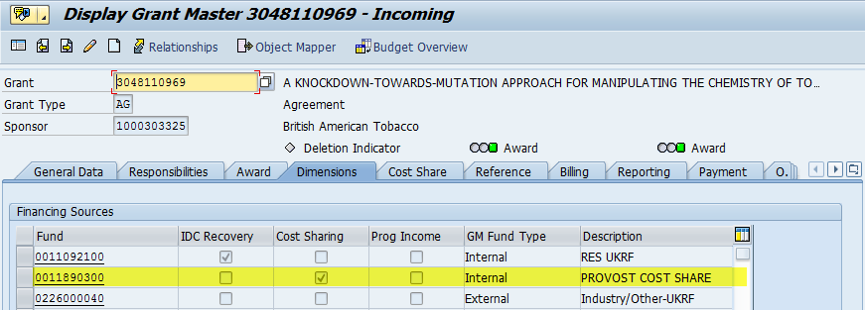

To review cost share transactions in BW using the Grant Ledger:
- Go to BW Web Reporting on the IRIS Launch Pad
- Click on FI Ledger Sheets -> Grants Management, then select Grant Ledger – PI Summary (or version of choice) using saved view ZTMNAVI0_0100: Cost Share Balance by Dept.
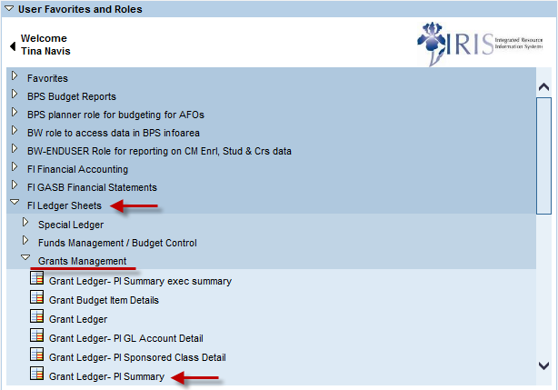

- Using the saved view, update the fiscal year and period (i.e. 004/2016) and department on the variable screen and execute the report.
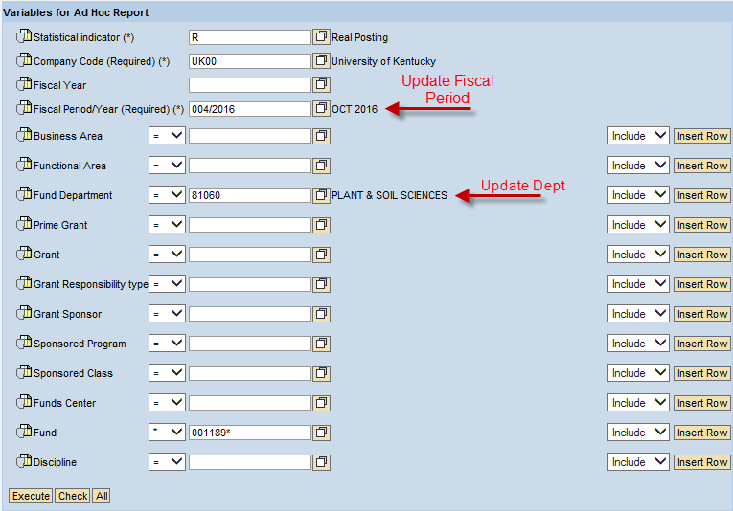
- The report shows the breakdown of entries by sponsored class.
- The funding totals are listed at the bottom of each project in the revenue sponsored classes.
- If the top result row for a project has a debit (positive) balance in the Cumulative PTD Expense column, funding is needed. A credit (negative) balance means overfunding.
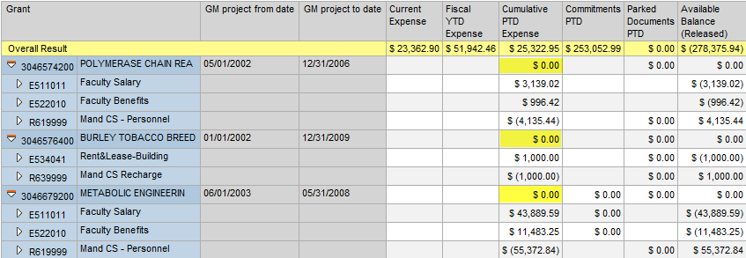
5. Funding Cost Share Expenses
Several general ledger (g/l) accounts are used to fund Cost Share. The debit (expense) entry will be to the Cost Center from which you are moving funds (750XXX g/l accounts). The credit (revenue) entry will be to the Grant with the Cost Share Fund (740XXX g/l accounts).
- 740510 Transfer from Cost Share – Salary Only
- 750510 Transfer to Cost Share – Salary Only
- 740515 Transfer from Cost Share – Benefits Only
- 750515 Transfer to Cost Share – Benefits Only
- 740520 Transfer from Cost Share – Operating Expenses
- 750520 Transfer to Cost Share – Operating Expenses
After typing in the Grant/WBS Element, also enter in the fund, do not let it derive the fund because SAP defaults to the external (Sponsor) fund.
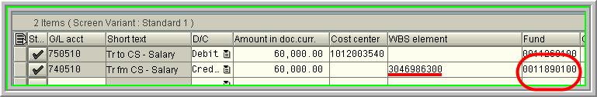
The College of Agriculture, Food & Environment participates in the automatic funding program. Departments have provided a single cost center to SPA which will automatically be charged for any expenses posted to the cost share fund for projects with the respective department listed as the responsible unit in SAP.
When the program is ran, it will distribute funding according to the categories that need funding – Salary, Benefits, and Direct Current Expenses on a cumulative basis. The funding will distribute to Salary (740510) first, then to Benefits (740515), and any remaining to Direct Current Expenses (740520). The overall funding will be distributed to cover the cost share balances. If the project is overfunded (funding>expenses), no entries will be made by the program. The program will also not “return” any overfunding on a project.
If funding needs to be charged somewhere other than the departmental cost share cost center, a JV will be required. When submitting JVs to transfer automatic funding between cost centers, it is helpful to include copies of the original funding entries. The instructions received from General Accounting for such entries are:
The departments will need to use the 75 GL accounts on both sides of the transactions between the cost centers. Also, they need to put the grants that are involved in each of the transactions in the Assignment field.
*Note: This exception has only been approved for those projects that are funded as part of the monthly program. If the funding is done via manual JV, a complete reversal and reentry of the funding are required.
An option to prevent the need for transfer of funding:
- A department who is not listed as the responsible unit but has cost share expenses on the project can submit a manual funding JV prior to month end for their faculty/staff (Generally monthly payroll is posted 2-3 days before the actual calendar month end if actuals are required). As long as the manual funding JV is posted prior to the automatic funding program (ran the 3rd business day after calendar month end), then the program will include the entry when comparing expenses vs. funding.
6. Project Close Out
Prior to the end date of a project (typically 60 days from the final report due date) SPA will send a reminder regarding the final fiscal report. The following items are noted as part of SPA’s review. Note that any commitment/obligation not fulfilled prior to close out may potentially be met by moving expenses previously posted to the sponsor fund to the cost share fund. It is recommended to review all project commitments at least quarterly.
COST SHARE
  - Please review your Cost Share Information Sheet, if applicable, and guarantee that the commitment made is fulfilled, posted correctly to the IRIS-FES system and fully funded. If outside of the IRIS-FES system, please make sure it is documented correctly and sent to Sponsored Projects Accounting for verification. Any unfulfilled commitments could result in a reduction of budget and refund to the sponsor. Any refund amounts resulting from unfulfilled cost share commitments will be charged to your department.

